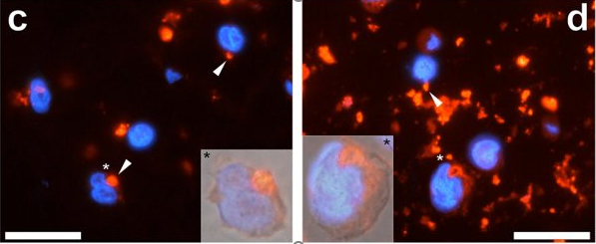
Fig.2.THP-1 cells (monocytes) co-cultivated with aluminum, colored with Lumogallion in agar-paraffin fixed (2 m slices). Augmented views of single cells are displayed in magnified inserts. Individual and identifiable adjuvant nanoparticles are highlighted with white arrows. Magnification × 1,000, scale bars: 20μm.
The Creative Commons CC-BY license governs the usage of this image, which allows for free use, sharing, and copying in every format as long as the original project is properly cited. Source: [33].

