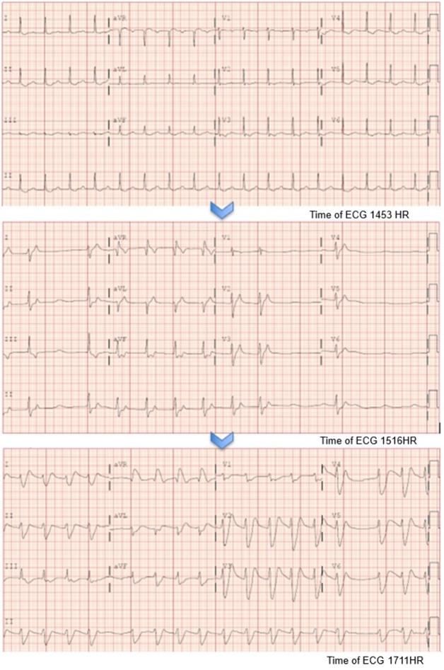
Figure 1: First ECG demonstrated first degree AV block with PR of 206 msec and T-wave inversions in the anterolateral leads. Subsequently, junctional rhythm evolved into idioventricular rhythm despite medical therapies.

