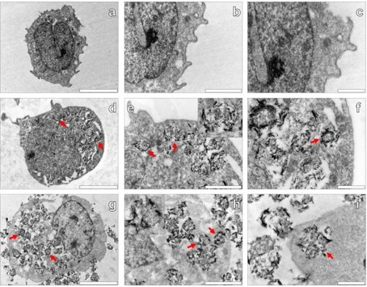
Fig.1. “Transmission electron microscopy (TEM) research of natural THP-1 cells (a–c), THP-1 cells co-cultured with 50 μg/mL AlO(OH) Sigma adjuvant (24 h) (d–f), and THP-1 cells co-cultured with 200 μg/mL AlO(OH)Sigma adjuvant (24 h) (g–i)”.The Creative Commons CC-BY license governs the usage of this image, which allows for free use, sharing, and copying in every format as long as the original project is properly cited. Source: [43].

