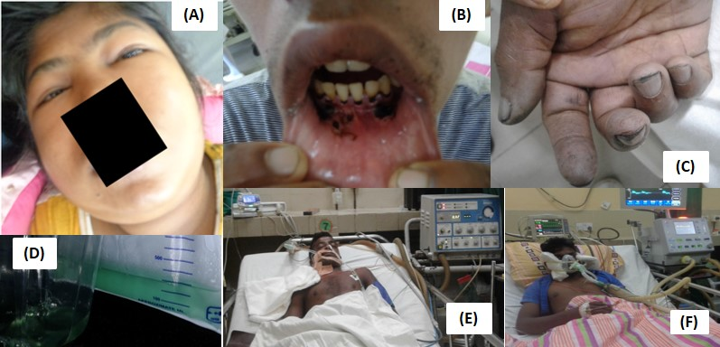
Figure 1. Clinical manifestations of ‘Prinso’ poisoning: (A) periorbital swelling on day 2 of oxalate poisoning in SN 68 patient (B) mouth ulcers on day 2 following both oxalate and permanganate poisoning (C) Peripheral cyanosis of fingers on day 1 following permanganate poisoning in SN 51 patient (D) Greenish color urine produced with the administration of methylene blue (antidote for KMnO₄) in SN 211 patient (E) Mechanical ventilation (SIMV mode) for respiratory failure (SN 211 patient) on day 1 following both oxalate and permanganate poisoning (F) Mechanical ventilation (C-PAP mode) for respiratory failure (SN 150 patient) on day 1 following both oxalate and permanganate poisoning

