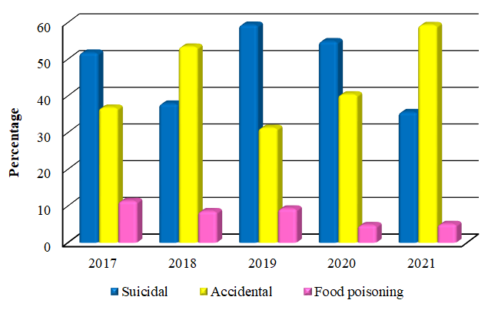
Figure 2. Frequency distribution of acute poisoning cases according to circumstances of poisoning 2017-2021

