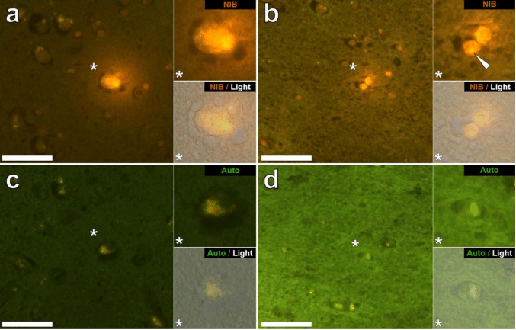
Fig. 3. “Lumogallion-reactive aluminium in likely neuronal and glial cells in the temporal lobe and hippocampus of a 14-year-old male donor (A10), diagnosed with autism. Intraneuronal aluminium in the temporal lobe (a) was identified via an orange fluorescence emission, co-deposited with lipofuscin as revealed by a yellow fluorescence in the non-stained autofluorescence serial (5μm) section (c). Intracellular punctate orange fluorescence (white arrow) was observed in glia in the hippocampus (b) producing a green autofluorescence emission on the non-stained section (d). Upper and lower panels depict magnified inserts marked by asterisks, of the fluorescence channel and bright field overlay. Magnification X 400, scale bars: 50μm”. The Creative Commons CC-BY license governs the usage of this image, which allows for free use, sharing, and copying in every format as long as the original project is properly cited. Source: [83].

