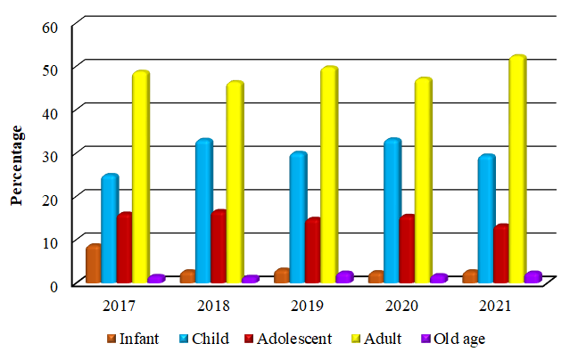
Figure 1. Frequency distribution of acute poisoning cases according to age group 2017-2021

